CREATING AWS FREE TIER ACCOUNT

Step1: Go to aws.amazon.com and click on Sign In to the Console.

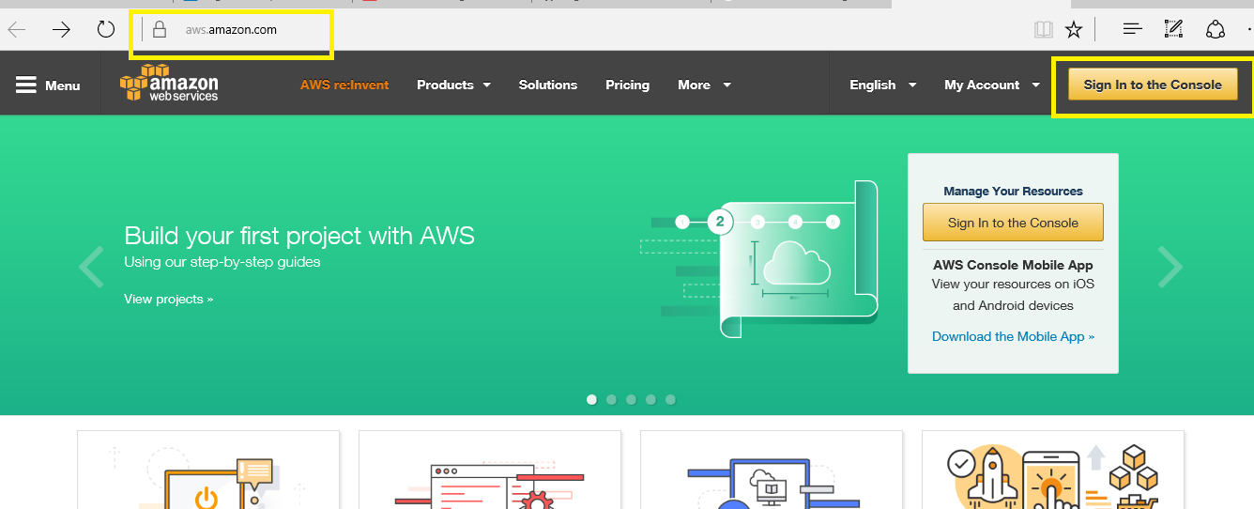

Step2: Enter your Mail Id and select ‘I am a new User’ and click on ‘sign in using our secure server’

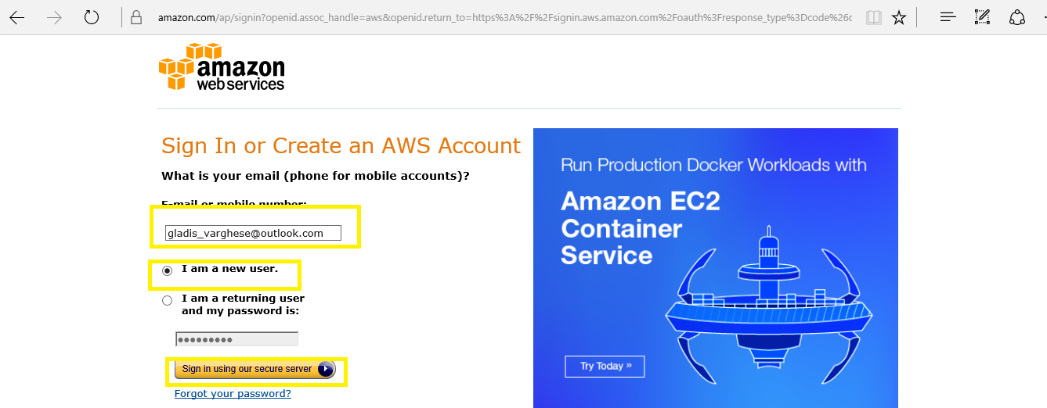

Step3: Enter your Login Credentials and click on create account.

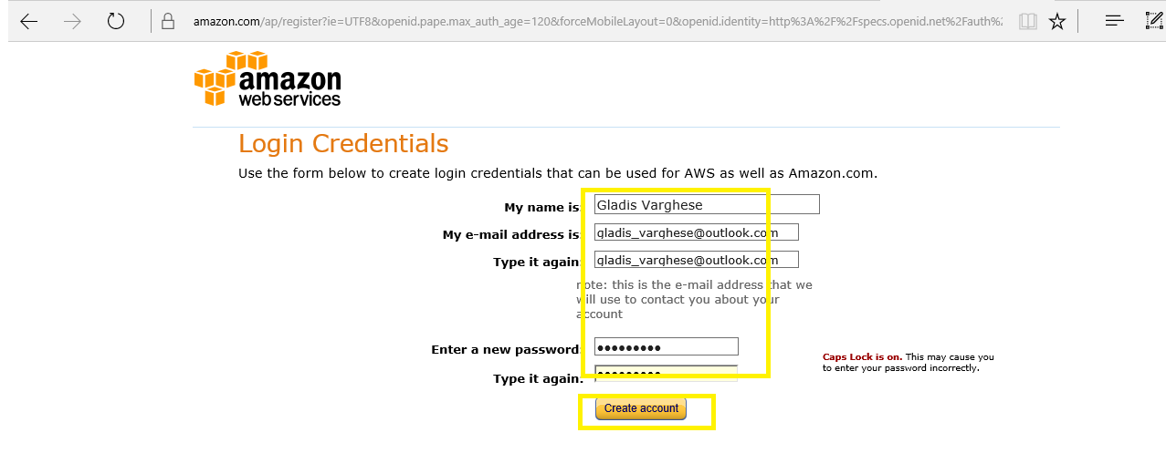

Step4: Enter your contact information and click on ’Create account and continue’

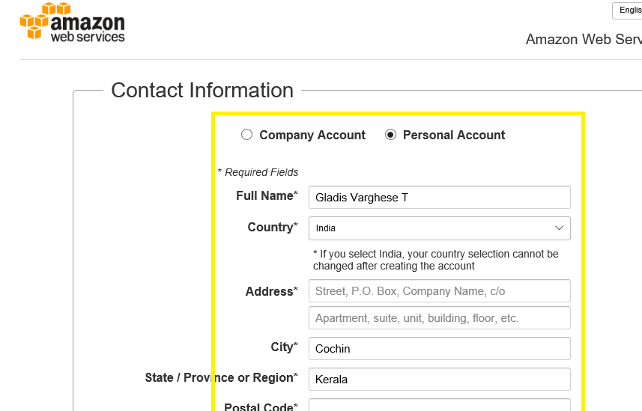

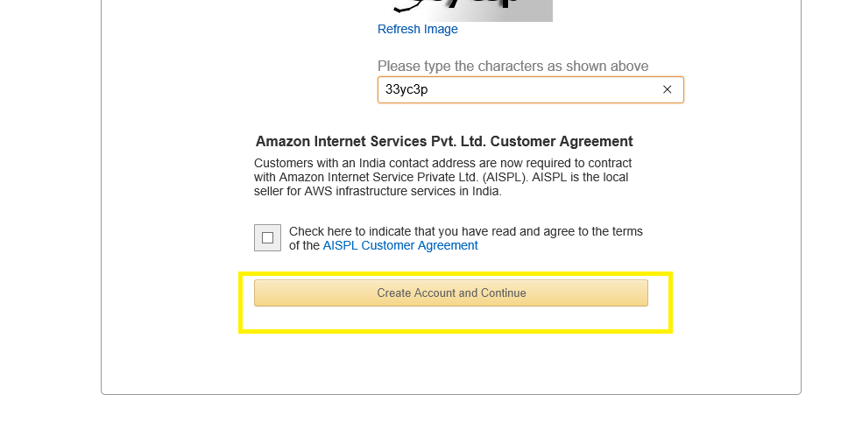

Step5: Enter Payment details and click on ‘Verify card and continue’

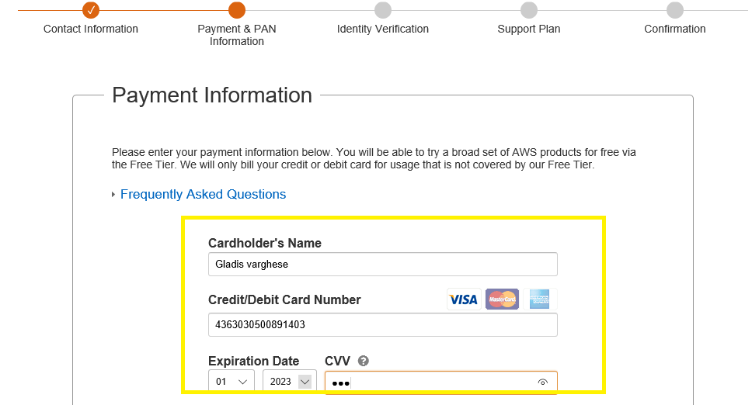

Step6: Enter the OTP received at your phone number.

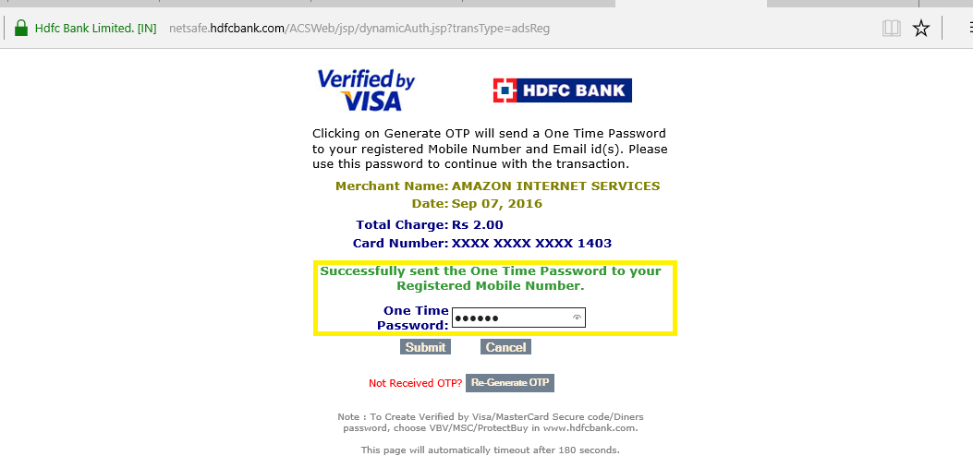

Step6: Pin provided by AWS should be entered from your phone to complete the Identity verification.

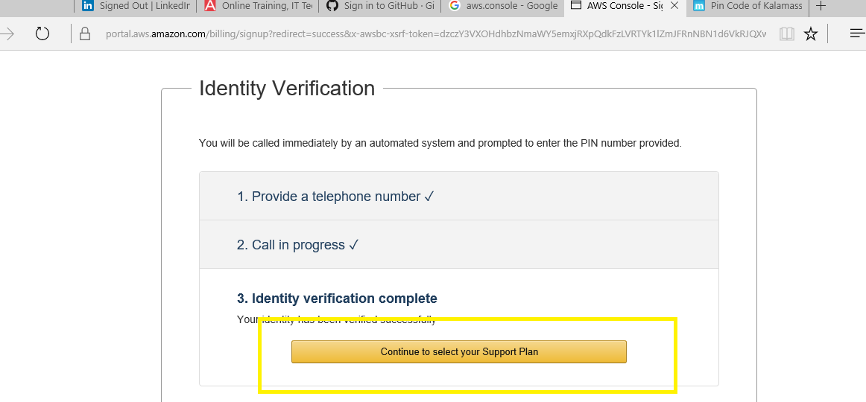

Step7: Select ‘Basic’ support plan and click on ‘Continue’

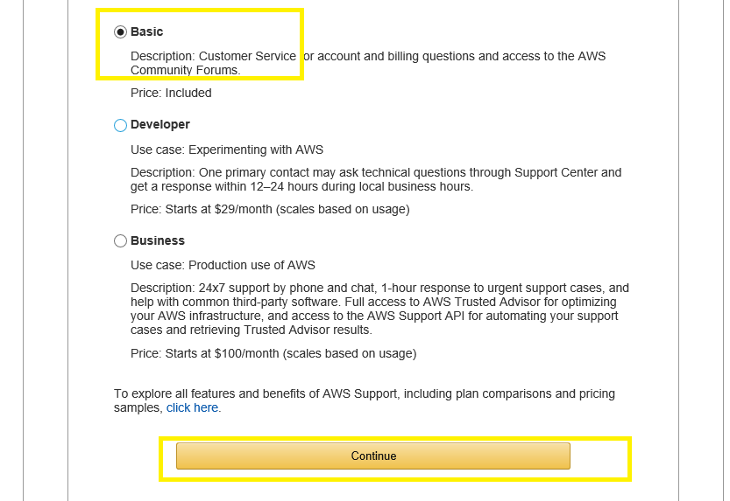  
Step8: Registration Confirmation page will appear and Click on ‘Sign in to console’

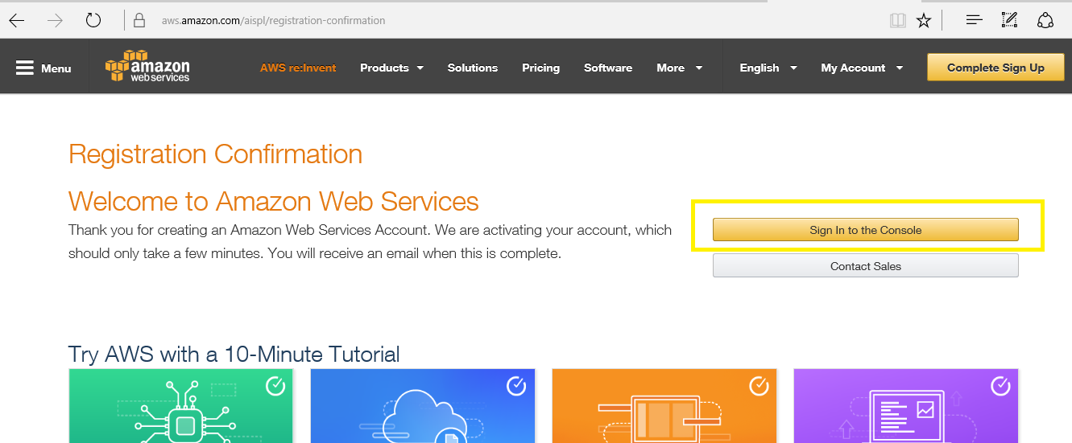

Step9: Enter Mail ID and password to sign in to your newly created AWS free tier account

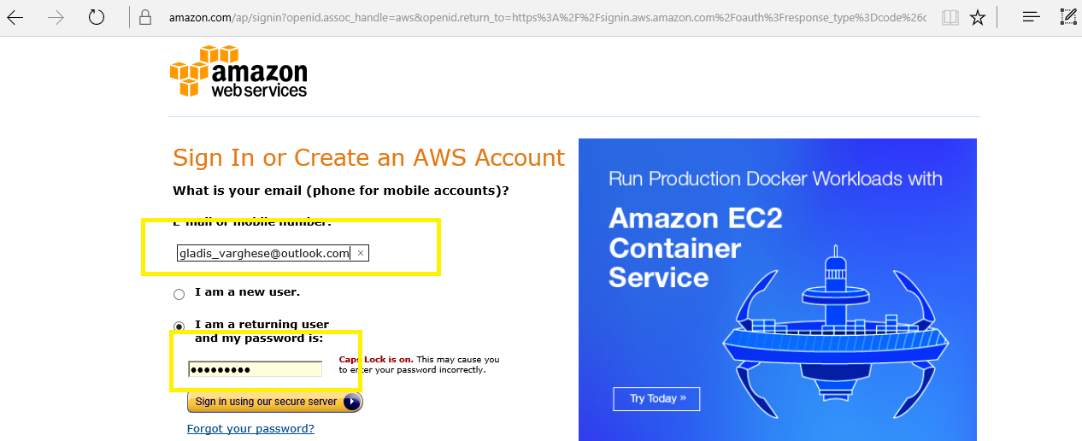

Step10: Your Amazon Console home page will appear

